Use the returns data set as well along with superstore dataset (available as attachment). The dataset contains order id of all return orders and return reason.

1. What are the total sales of return orders for each year.

Answer:

2021 75,502.06

2020 36,121.77

2019 39,660.89

2018 29,219.55

1. Which subcategories do not have all 3 types (return reason) of returns.

Answer: Supplies, Labels, Fasteners, Copiers, Bookcases

1. How many cities do not have any return orders.

Answer: 412

1. Show the trend of return orders over the years by sales and count of orders in a dual axis chart.

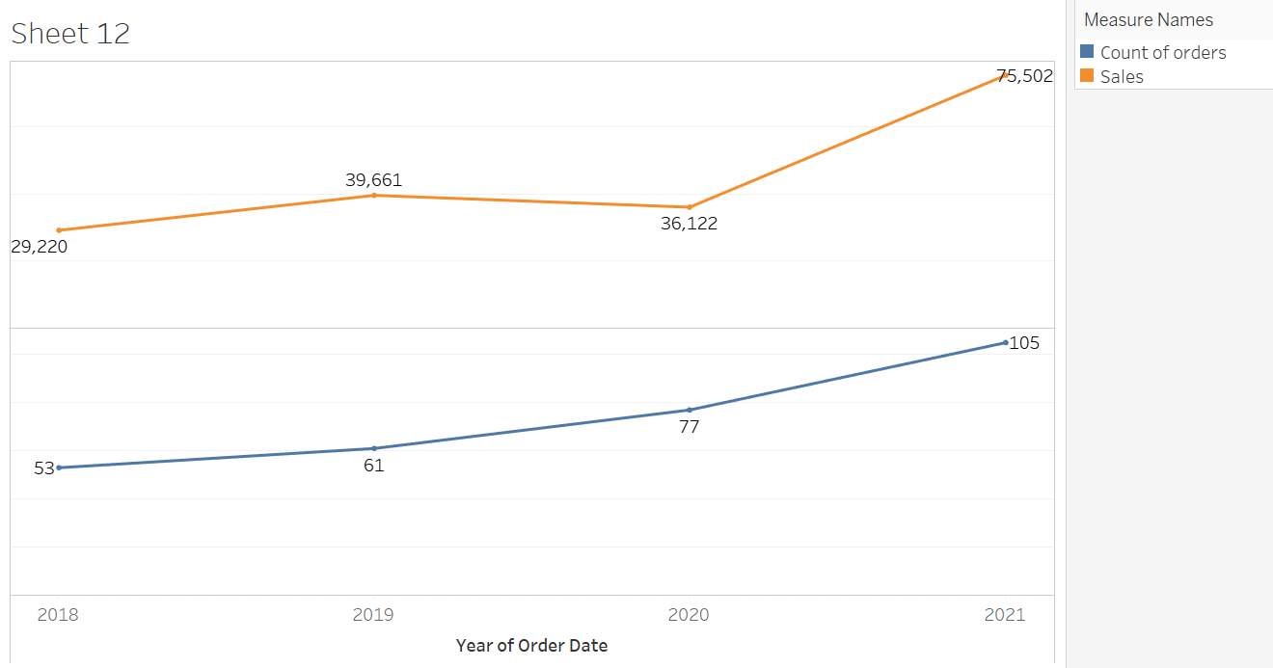

1. Which profitable sub-category or sub-categories has been bought by less than 100 customers?

*Answer: Machines, Copiers*

1. Which year and month was the best year and month for Technology product sales? Take “best” to mean the year and

month that had the most sales amount for the criteria provided.

*Answer: November, 2021*

1. Which sub-category has the highest profit to sales ratio?

*Answer: Labels*

1. Which product has the widest profit range? (get min/max profit and check range)

*Answer: OFF-BI-10001120 - Ibico EPK-21 Electric Binding System*

1. How many customers ordered in June 2021? (ie they made an order between Jun 1 – 30, 2021)

*Answer: 118*

1. How many customers first ordered in June 2021? (ie they made an order between Jun 1 – 30, 2021)

*Answer: 1*

1. The product that had the second highest sales in 2018 was ranked what in 2021?

*Answer: #10*

1. Who among our most loyal customers (customers who bought at least once each year) bought the most from us (ie have the highest sales)?

*Answer: AB-10105 – Adrian Barton*

1. How many products are in the top 20 for both years 2020 and 2021?

*Answer: 7*

1. If discount amount is discount multiplied to sales amount, which customers from each region received the most discounts?

*Answer:*

*Central – Becky Martin (BM-11140) East – Cindy Stewart (CS-12505) South – Sean Miller (SM-20320) West – Sharelle Roach (SR-20425)*

1. Create a bar chart which shows profit by each year-month. If the profit is more than 0 then bar should be GREEN color else it should be RED.

